Current Network Setup - CentOS Server

Server Type: CentOS
Student Name: Gabriel Moreira

How Networking Works on This Server by Default
This CentOS server uses NetworkManager as its primary network management service, which runs automatically in the background to control all network connections. By default, the network interface is configured to obtain an IP address automatically through DHCP from the network's DHCP server.

Network configurations are stored in plain text files located at /etc/sysconfig/network-scripts/, with each network interface having its own configuration file named ifcfg-[interface-name]. DNS resolution is managed through /etc/resolv.conf, which NetworkManager typically generates automatically based on settings received from DHCP or manual configuration.

To find all relevant network information on this server, I use commands like ip addr show to view interfaces and IP addresses, ip route show to check routing, nmcli connection show to see configured connections, and systemctl status NetworkManager to verify the network service is running. All network-related scripts I've created are stored in /home/gabrielmor/scripts/, configuration files are in /etc/sysconfig/network-scripts/, and the primary networking tool is nmcli for managing connections via NetworkManager.

Current Network Configuration

Network Interfaces
Command: ip addr show (will show the network configuration details)
Output:
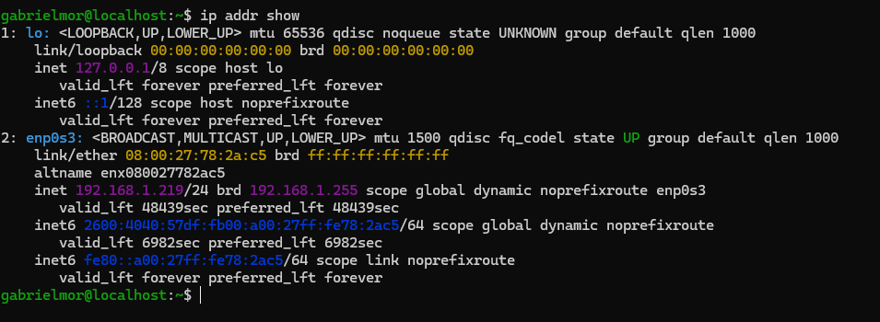

Configuration Type: DHCP

Gateway and Routing
To show the routing and gateway settings
Command: ip route show
OutPut:
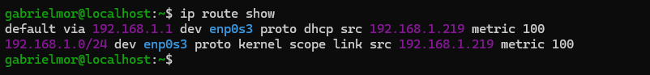

DNS Configuration
To view the dns configuration, run this command
Command: cat /etc/resolv.conf
Output:
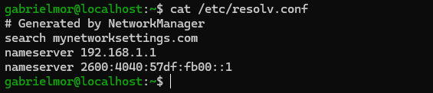
DNS Servers:
My primary and secondary dns servers are as follows:
- Primary: 192.168.1.1
- Secondary: 2600:4040:57df:fb00::1

NetworkManager Status
To view the status of the network manager wether it is active and running or not, do the below:
Command: systemctl status NetworkManager
Output:
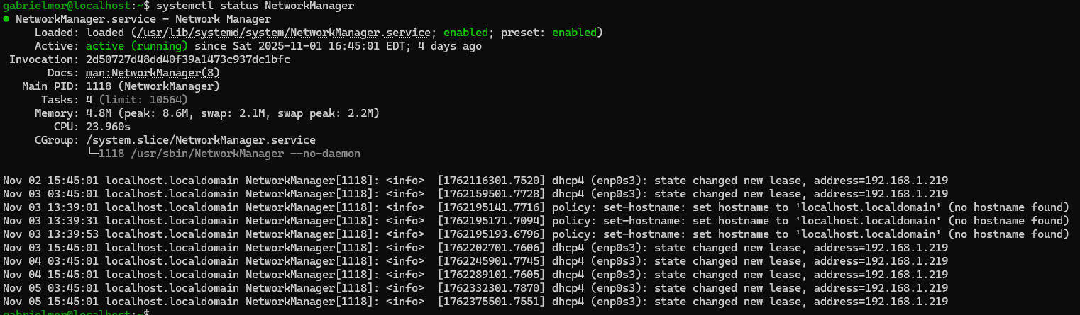
Service Status: [Active]

Installed Networking Packages
These are all the recent packages I installed on the server. Networking packages included
Command: rpm -qa –last | head -30
Output:
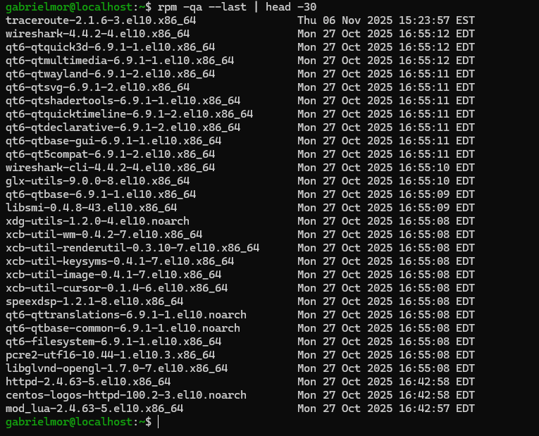

System Updates
The last full system update was done on the 11-06-2025. I used the command below to do a full system update.
Command: sudo dnf update -y
Output:
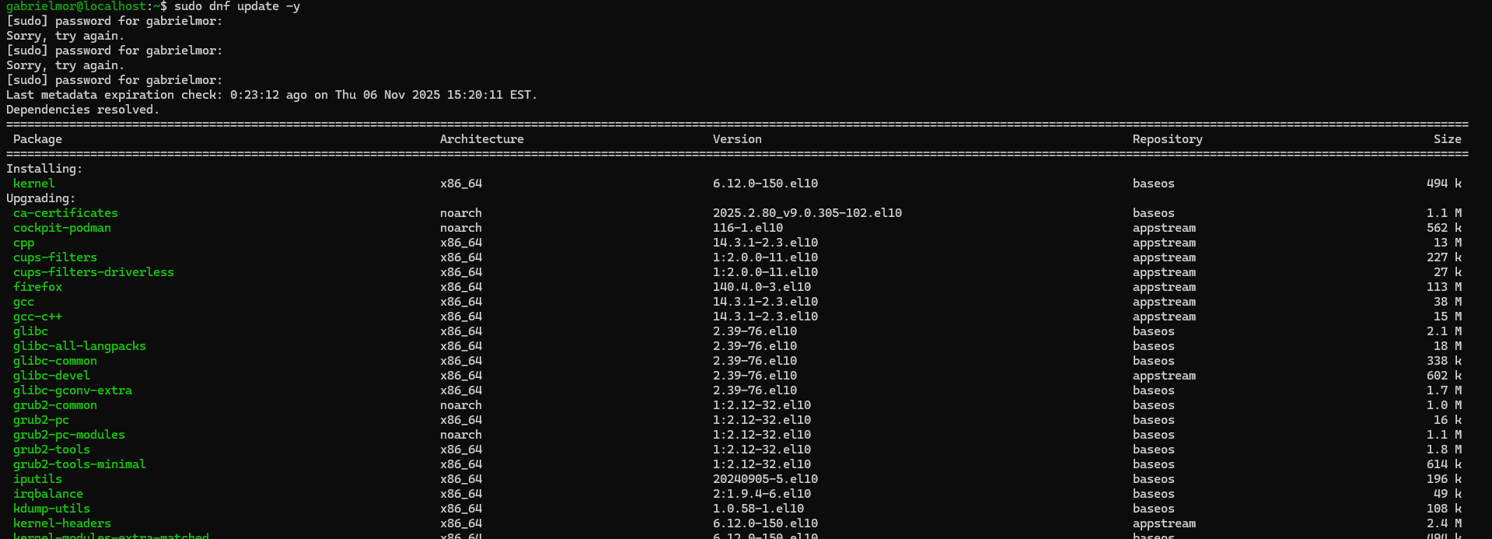

Location of Network Information
The table below shows the location of all the networking configuration files.
Type | Location | Purpose
Network Interface Configs | /etc/NetworkManager/system-connections/enp0s3.nmconnection | It is generally used for interface specific settings`
DNS Configuration | /etc/resolv.conf | Stores DNS settings
Hostname | /etc/hostname | Stores System hostname
Host mapping | /etc/host | Stores Ip address to host mappings

Custom Scripts
This table shows the locations of all the custom scripts I created and a brief of what they are used for
Script Name | Location | Purpose
network_info_dump.sh | /home/gabrielmor/scripts/ | The script collects comprehensive network info to a file
network_troubleshoot.sh | /home/gabrielmor/scripts/ | This script provides an interactive troubleshooting guide

Essential Tools and Commands
This table represent the network commands I use frequently to trouble shoot issues and run qucik checks and setup

Tool Name | Command | What it shows
IP configuration | ip addr show | It shows all network interfaces and IP addresses
Routing | ip route show
NetworkManager | nmcli connection show
DNS Testing | dig google.com
Connectivity | ping google.com
Path tracing | traceroute google.com

